Lab Task#1

Saad Ahmad

20P-0051

**Question#1**

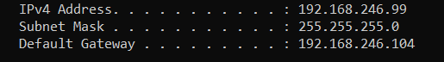

IP address: 192.168.246.99

Subset mask: 255.255.255.0

Default gateway: 192.168.246.104

**Question#2**

Host 1 = 172.17.2.69

Host 2 = 192.168.26.6

Host 3 = 172.17.1.173

**Question #3**

**OS** = Windows 11

**Way #1 (using cmd)**

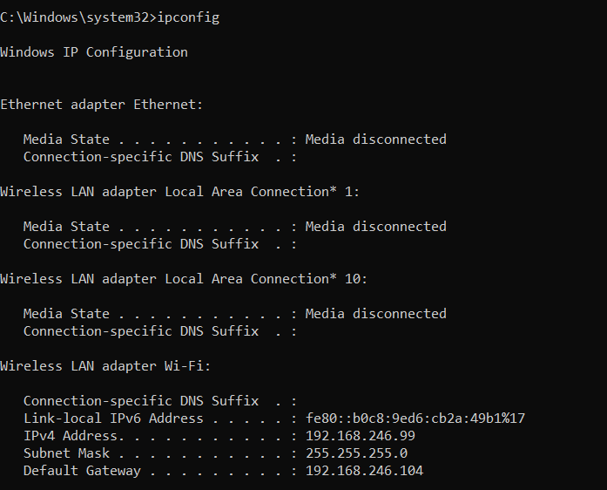

**Way #2 (using Settings app)**

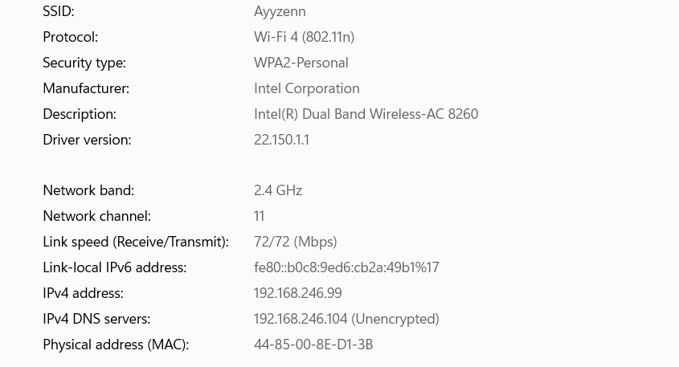

**Way #3 (using control panel)**

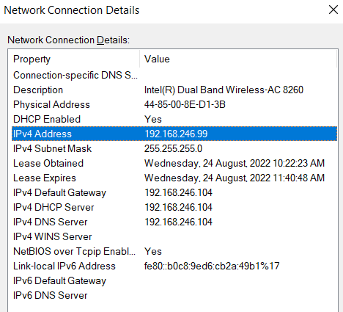

**Way #4 (using System Information)**

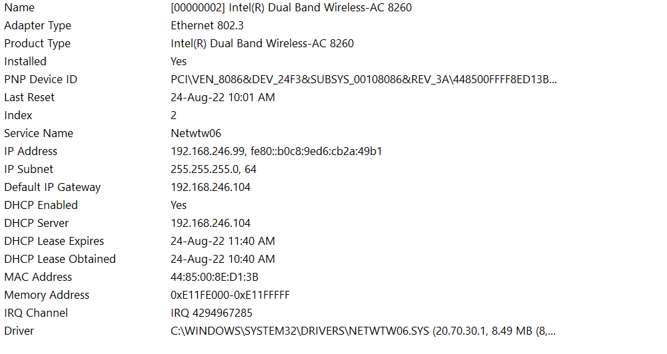

**Way #5 (using PowerShell)**

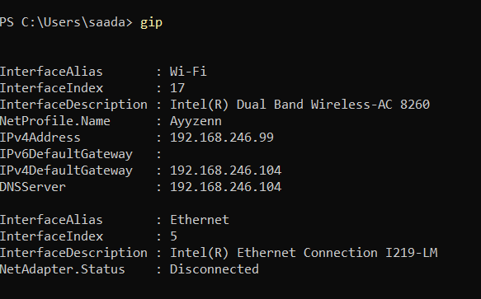

**Way #6 (using Task manger)**

